**FINAL Exam: DATABASE**

**WEP 2023**

**{3h 00}**

XX FEB 2023

**RULE:**

* Chatting and talking to other students is forbidden
* You are allowed to use PhpMyAdmin or VSCode or any other software
  + *But it is not required*
* Write (copy/paste) your answer below the question. Do not screenshot.
  + *ERD diagram you can screenshot and insert into this document*

**HOW DO I SUBMIT THE EXAM?**

* Save this document as a yourfullname.PDF file
* Export your database *(for Exercise 02 Hospital management system)*
* In Google Classroom attach these two files to submit.

|  |  |
| --- | --- |
| **EXERCISES** | **POINTS** |
| EXERCISE 1 | 40 |
| EXERCISE 2 | 60 |
| **TOTAL** | **100** |

# Exercise 1 – PNC’s Facebook

Before start:

* Open **PHPMyAdmin** and import the database named: *pnc_facebook.sql*

We want to have an application for PNC’s students to post events, like Facebook.

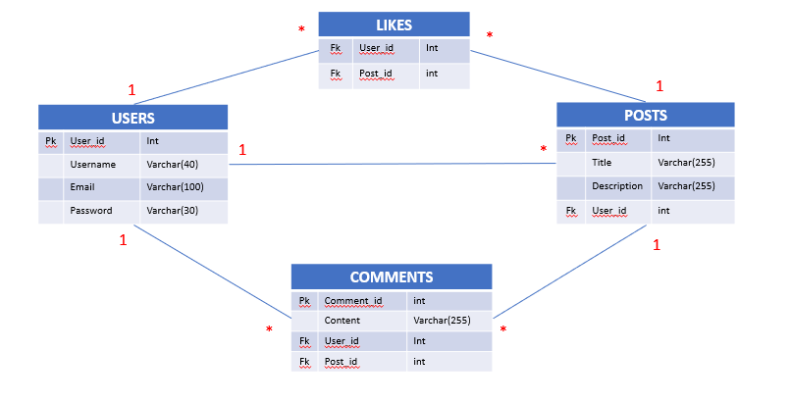

**Q1 – (10 POINTS):** Write a SQL statement to display all comments for the user named “**Kassia Lyfield**”

**Q2 – (10 POINTS):** Write a SQL statement to display the username of who posted the most.

**Q3 – (10 POINTS):** Write a SQL statement to display the most popular posts.

**Q4 – (10 POINTS):** Write a SQL statement to display the number of likes for each post.

# Exercise 2 – Hospital Management System

A lot of nurses in Cambodia have a problem with checking the available rooms and beds for patients. So, they propose the IT staff make an application to manage rooms and beds in the hospital. Below is the information that they wanted to store:

* **Hospitals**: have a name and address.
* **Rooms**: have a name.
* **Beds**: have a code *e.g. C02*
* **Patients**: have a name and phone.

Additional information about the relations between entities:

* A hospital has many rooms.
* A room has one or many beds
* A room has a type *e.g. VIP, Normal.*
* A bed has only one patient, and a patient belongs to one bed.

**Q1 – (20 POINTS)** Design the ERD Physical Model related to this problem

* Create your ERD in the file EXERCISE-2-ERD.PPTX
* include the keys, types, and all necessary tables

**Q2 – (5 POINTS)** Write the SQL statement to create all of these tables in your database.

**Q3 – (10 POINTS) -** Write the SQL statement to insert data following the scenario below:

Russian Hospital registered to use this application. Below is the information they need to store:

* + Address: Sangkat Tek thlar khan Sen Sok, Phnom Penh
  + There are 5 rooms (name: R01, R02…., R05)
  + R01 and R02 is the VIP room and has only one bed for each room *(e.g. R01 has a bed’s code R011, and R02 has a bed’s code R022).*
  + There are 11 patients in this hospital *(Insert these 11 patients with fake data by yourself.)*
  + Room R01 has a patient whose patient ID is 1.
  + The other three rooms are NORMAL rooms. Each room has 5 beds.
    - R03 has beds R031, R032, …, R035
    - R04 has beds R041, R042, …, R045
    - R05 has beds R051, R052, …, R055
  + All beds in room R03 and R04 already have patients *(you can key patient with bed, but make sure maximum 1 patient to a bed).*

**Q4 – (10 POINTS) -** Write a SQL statement to create a **VIEW** named “**Number_Of_Beds_In_Each_Room**” to show number of beds in each room

**Expected result:**

|  |  |
| --- | --- |
| **Room** | **Number of beds** |
| R01 | 1 |
| R02 | 1 |
| R03 | 5 |
| R04 | 5 |
| R05 | 5 |

**Q5 – (15 POINTS) -** Write a SQL statement to create a **VIEW** named “**Available_Beds**” to show all the free beds in all rooms.

**Expected result:**

|  |
| --- |
| **Room** |
| R051 |
| R052 |
| R053 |
| R054 |
| R055 |